There are three commonly used excitation modes for step motors; these are full step, half step and microstepping.

In full step operation, the motor moves through its basic step angle, i.e., a 1.8° step motor takes 200 steps per motor revolution. There are two types of full step excitation modes. In single phase mode, also known as “one-phase on, full step” excitation, the motor is operated with only one phase (group of windings) energized at a time. This mode requires the least amount of power from the driver of any of the excitation modes. See Fig. 5a.

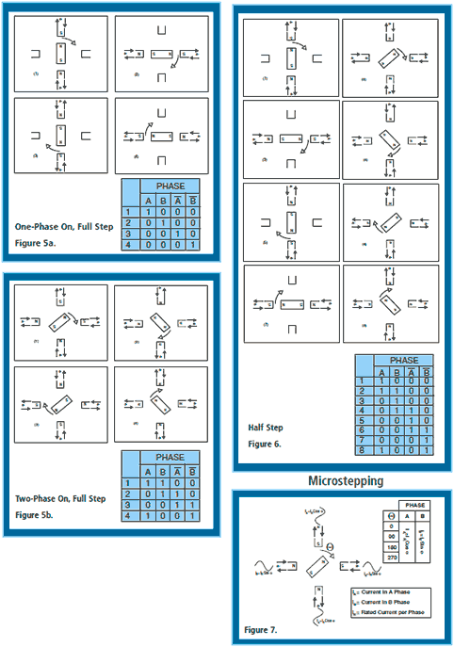

In dual phase mode, also known as “two-phase on, full step” excitation, the motor is operated with both phases energized at the same time. This mode provides improved torque and speed performance. Dual phase excitation provides about 30% to 40% more torque than single phase excitation, but does require twice as much power from the driver. See Fig. 5b.

Half step excitation is alternating single and dual phase operation resulting in steps that are half the basic step angle. Due to the smaller step angle, this mode provides twice the resolution and smoother operation. Half stepping produces roughly 15% less torque than dual phase full stepping. Modified half stepping eliminates this torque decrease by increasing the current applied to the motor when a single phase is energized. See Fig. 6.  
Microstepping is a technique that increases motor resolution by controlling both the direction and amplitude of current flow in each winding. Current is proportioned in the windings according to sine and cosine functions.

Microstepping can divide a motor’s basic step up to 256 times. Microstepping improves low speed smoothness and minimizes low speed resonance effects. Microstepping produces roughly 30% less torque than dual phase full stepping. See Fig. 7.

**More on Microstepping**

What is the goal of microstepping? Essentially, the goal of this process is to create a motor that runs as smoothly as possible. Due to the nature of step motors, their rotation is not entirely smooth, as the motor is moving “step by step”. Of course, these steps are designed to be moved through rather quickly, so there is usually no particularly detrimental effect on performance, but for those who require smoother resolution, the full step stepper motor may not be quite what is needed.

This is where the microstepper controller comes in. The microstepper controller is a driver that sends pulses to the motor in an ideal waveform for fluid rotation. The idea is for the driver to send current in the form of sinewaves. Two sinewaves that are 90 degrees out of phase is the perfect driver for a smooth motor. If two step coils can be made to follow these sinewaves, it results in a perfectly quiet, smooth motor with no detectable “stepping”.

This is because, in such a case, the two waves work together to keep the motor in smooth transition from one pole to the other. When the current increases in one coil, it decreases in the other, resulting in smooth step advancing and continuous torque output at each position. A normal bipolar stepper driver does not have these smooth wave forms. As a result, the motor transitions are not as smooth. In most applications requiring stepper motors, assuming an ideal driver situation. In reality, the wave forms can deviate significantly, resulting in what is called “resonance”, which is a phenomenon that creates problems for mechanical systems. Microstepping reduces resonance issues by controlling the waves so that this type of deviation does not occur.

A microstepper controller subdivides the motor step angle into multiple divisions to improve control over the motor. This allows for more refined motor work that requires greater motor resolution. Keep in mind that while a microstepper controller may make this refined motion possible, there may be physical limitations in your machinery that affect the motion of the motor in your particular application. That being said, if you are doing precise work for which the threat of resonance is an issue, you definitely want to be looking into the use of a microstepping controller for your motors.